**Brooklyn torah gazette**

**For parshas ki seitzei 5782**

Volume 6, Issue 50 (Whole Number 305) 14 Elul 5782/ September 10, 2022

**Rabbi Akiba’s Daughter**

**And the Poisonous Snake**

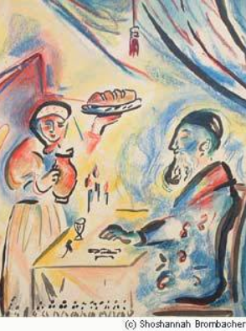

Rabbi Akiba’s daughter once went to the market to buy things for the home. As she passed a group of star-gazers and fortune–tellers, one of them said to the other: “see that lovely girl? What a dreadful calamity is awaiting her! She is going to die on the very day of her wedding. Mark my word!”

Rabbi Akiba’s daughter overheard the words of the star-gazer, but paid no attention to him. She had often heard it from her great father that he who observes the Mitzvoth of the holy Torah need fear no evil. As the happy day of her wedding approached, she had forgoten all about that star-gazer.

On the day before her wedding, there was much to do, and at night she retired to bed, tired but happy. Before going to bed, she removed her golden hair-pin and stuck it in the wall, as she had done before. The following morning, she pulled her pin from the wall, and in doing so dragged a small but very poisonous snake with it.

Horrified, she realized that she had killed the snake that was lurking in the wall's crevice when she stuck the pin into the wall the night before. What a wonderful miracle! Then she remembered the words of the star-gazer, and shuddered. She heard a knock on the door.

**Saw the Dead Snake**

“Are you alright, daughter? I heard you shriek,” her father said. Then he saw the dead snake still dangling from the pin. She told her father what happened. “This is indeed a miracle,” Rabbi Akiba said.

“Tell me, daughter, what did you do yesterday? There must have been some special Mitzvah that you performed yesterday to have been saved from this.”

“Well, the only thing that I can remember was this. Last night, when everybody was busy with the preparations for my wedding, a poor man came in, but nobody seemed to notice him, so busy everbody was. I saw that the poor man was very hungry, so I took my portion of the wedding-feast and gave it to him.”

Rabbi Akiba had always known that his daughter was very devoted to the poor, but this was something special, and he was very happy indeed. “Tzedoko (charity) delivereth from death,” (Mishlei 10:2) he exclaimed. (Shabbat 156b - Rabbi Nissan Mindel - Chabad.Org)

*Reprinted from this week’s email of R’ Yedidye Hirtenfeld’s whY I Matter parsha sheet for the Young Israel of Midwood in Brooklyn.*

**Your Brother’s Donkey**

“Do not observe your brother’s donkey or his ox falling and turn yourself away — you shall surely help it up.” (22:4)

R’ Yaakov Yosef Hakohen of Polnoye z”l (1710-1784; author of the first Chassidic work and a primary source for the teachings of the Ba’al Shem Tov) interprets this homiletically:

“Do not observe your brother’s donkey or his ox falling”–it would be better not to see your brother in a state of spiritual decline (becoming like a donkey or an ox). “Turn yourself away.” But if you do see, “You shall surely help [him] up.” (Toldot Yaakov Yosef)

*Reprinted from this week’s email of R’ Yedidye Hirtenfeld’s whY I Matter parsha sheet for the Young Israel of Midwood in Brooklyn.*

**Rav Avigdor Miller on**

**Big Small Achievements**



**QUESTION:** **What should a person do if he wants to become great but he realizes that he lacks the motivation to accomplish it to the fullest extent that he desires?**

**ANSWER:** Look.  Here’s a man who would like to become a millionaire.  He’s walking in the street and he sees a measly twenty dollar bill lying in the gutter. Now, twenty dollars won’t make him a millionaire but will he pass by?  No. Even a millionaire will stoop down and pick it up.

And the answer is, every little bit is valuable.  If you’re able to control your character at least one little bit, a little tikkun, that’s already valuable. If you keep quiet a little bit – if instead of talking a thousand words a day, you’ll talk 999 words, it’s already a big achievement.

And therefore, it’s only because people don’t realize how great is the achievement in ruchniyus, they don’t realize that when it comes to the spiritual achievements of improving your character even the smallest amount is worth doing, that’s why people don’t grab the opportunities.

And therefore nobody should disdain that; just because he cannot become a tzaddik like Moshe Rabbeinu doesn’t mean he shouldn’t bend over and pick up the twenty dollar bill anyhow.

*Reprinted from the August 23, 2022 email of Toras Avigdor (Tape E-1, February 1995)*

**The Great Promise that**

**Moshiach will Bring to All Jews**

**From the Talks of the Lubavitcher Rebbe**

**Rabbi Menachem Mendel Schneerson, Zt”l**



This week we read the Torah portion of Ki Teitzei. The Haftora is a prophecy Yishayahu (Isaiah).

The Haftora has a double theme. First, when Moshiach comes, things will be so good that we will forget the hardships of the exile. Second, the redemption will be absolute, never to be followed by another exile.

The Haftora begins, "Sing, barren one, who has not given birth." Who is this barren one?

**Feeling Like a Barren Woman**

A simple explanation is that G-d is talking to the city of Jerusalem, which feels like a barren woman, who has never given birth, because she is desolate during this long exile. G-d tells her to sing, as now that Moshiach is here, her streets are once again filled with her children and she doesn't feel barren any more.

On a deeper level, G-d is talking to the Jews who claims that the Jewish people are barren and have not given birth to him. Meaning, he has totally disassociated himself from the Jewish nation. G-d is saying that even the person who is unaffiliated or disaffected will sing the song we will sing when Moshiach comes.

The revelation will be so great that we will break out in song, just as we did at the splitting of the sea. Every Jews will be included, even the "barren" one, who is in the darkest place. The revelation and transformation will be so great, that s/he too will break out in song.

**A Fleeting Dream**

The exile will then seem as a fleeting dream as the Haftora says, "For a brief moment I forsook you." This will be because, as the verse continues, "with great compassion I will gather you." The next verse continues, "With a little wrath, I hid my face from you for a moment, but with everlasting kindness, I will have compassion on you... "

What is clear from these verses, is that when Moshiach comes, it will be so good, that the exile will feel like we endured it only for a brief moment.

Now the Haftora says, "Like the waters of Noah, this is to Me, just as I swore to never again cover the earth with the waters of Noah, so have I sworn not to be wrathful with you and not to rebuke you (ever again)." G-d calls the flood "the waters of Noah" because the name "Noach" is like the word "nachat," - pleasure - indicating that the floor was positive and changed the world for good. The same is true about this exile. When Moshiach comes, we will see how everything we went through in this exile directly made the world ready for Moshiach. We will see the positive in it all.

**The Darkness of Exile**

Like beacons of light, this Haftora is read two times in the year - once with the portion of Noach at the beginning of the year and now at the end of the year - to remind us that though our work is difficult and the exile is dark, what we are accomplishing is tremendous and our reward is even greater.

*Reprinted from Issue 1589 of L’Chaim for Parshas Ki Teitzei 5779/2019. Adapted by Rabbi Yitzi Hurwitz from the teachings of the Rebbe, yitzihurwitz.blogspot.com. Rabbi Hurwitz, who is battling ALS, and his wife Dina, are emissaries of the Rebbe in Temecula, Ca.*

**Rabbi Berel Wein on**

**Parshat Teitzei 5782**



This week’s Torah reading begins with all the ills that can befall a domestic society. These include lust and exploitation of other human beings, especially women by men in a dominant male society; unhappy marriages, dysfunctional families and disputes over inheritances that wreck family life. Seriously troubled, rebellious, and violent children that defy all authority, especially parental authority is also discussed. We are all witness, almost daily, to these circumstances in our general and specific societies.

The Torah in this parsha deals only with the treatment of the symptoms and not with the pathology that lies behind the problems. It attempts to protect the abused woman, to bring order into the rights and priorities of potential heirs and to punish the wayward son. Yet it does not directly comment on the underlying causes that generate these heartbreaking problems.

It is not that the Torah is unaware of the causes of the problems that it describes. Rather, the Torah always “descends into the exploration of the human psyche” and always presumes that in spite of all of its warnings, commandments and values, human beings – good decent people – fall prey to weaknesses and do not wish to gaze at the consequences of their behavior.

If all of the preceding parshiyot of the Torah did not impress the reader regarding how to raise children, how to enter and conduct a marriage, how to treat other human beings with dignity and respect, then repeating these lessons now is almost useless. The Torah merely points out for us that the facts, the results of life and our previous behavior in it, speak for themselves in the results that now face and challenge us. We already know the causes for these problems. The Torah now wishes us to see the results for ourselves as they manifest themselves in our lives.

There is also an element present in our lives that always remains inexplicable to human reasoning and understanding. The greatest, smartest and most wonderful parents sometimes raise dysfunctional if not even monstrous offspring. The example of Yitzchak and Rivka with Eisav or of King David with Avshalom rise before us

And the opposite situations as well, where people of dubious character and sinful behavior raise children of outstanding merit such as Terach with Avraham or Lavan with Leah and Rachel. In short, quick and easy judgments as to the causes of family behavior in these matters are not in place. There are too many variables and the freedom of choice entrusted to every human being, for good or for better, remains paramount in human behavior.

Therefore, perhaps the Torah does not dwell upon the deeper causes of the dysfunctional and wrongheaded behavior that it describes in the parsha. Instead it concentrates upon the behavior itself and its resultant problems and consequences. The hidden things belong to an inscrutable Heaven, but it is our task to do the best we can to follow the general principles and values as well as the specific commandments of the Torah, and pray to God for success and achievement.

Shabat shalom.

*Reprinted from the current website of rabbiwein.com*

**Why I Took My Family**

**Back to the NICU**

**By**[**Sarah Pachter**](https://aish.com/authors/48867412?aut_id=6612)

*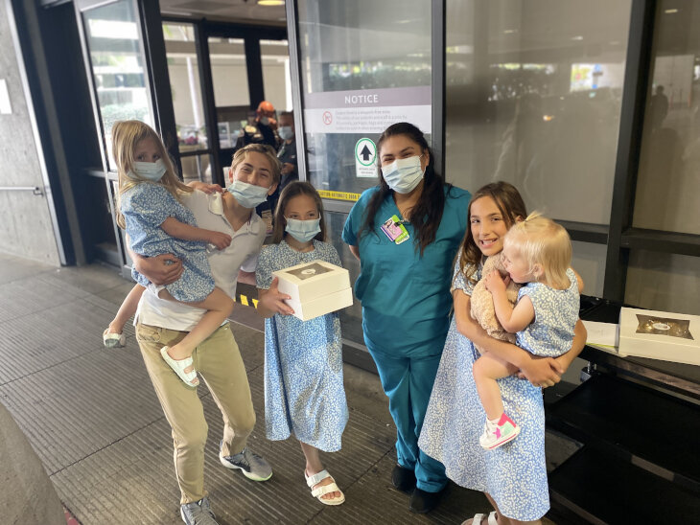The Pachter kids with a nurse from NICU*

*My kids received an unforgettable lesson in gratitude.*

My third child, Emunah, was born with the umbilical cord wrapped around her neck. The doctor quickly untangled it, and even though I had subsequent hemorrhaging, the baby was healthy. We went home a few days later.

The first night home, Emmy cried uncontrollably. Despite every effort, I couldn’t console her. The following morning I took her for a check-up. After testing, we were rushed straight to the NICU because her jaundice had spiked and the situation was grave. We spent a week in the hospital.

That was one of the hardest weeks I had ever endured. I was still weak. I was pumping excessively, and my husband was delivering the milk to the hospital at all hours. I sat by the baby’s incubator, unable to hold her, touch her, or feed her. I felt numb. I felt guilty leaving my children when I was at the NICU, and even more guilty when at home with my other children. I wished I could clone myself.

#Hours spent sitting in traffic? *No problem, my baby is alive!*

I was emotionally and physically exhausted, but overjoyed when we were able to bring Emunah home, just hours before the start of Yom Kippur.

For weeks, my happiness level was at an all-time high.

Burnt meatballs? *Who cares! My baby is alive!*

Hours spent sitting in traffic? *No problem, my baby is alive!*

I was overwhelmed with joy, but the happiness high didn’t last.

As part of a happiness project for my upcoming book, I’ve been experimenting with the effects of appreciation.

An article in the*Journal of Social and Clinical Psychology* concluded that gratitude has the highest connection to mental health and happiness than any other personality trait studied.

**Maintaining a Gratitude Log**

That’s why I’ve maintained a [gratitude](https://aish.com/48942481/) log for the past 18 years. It helps me feel happy.

I logged the simplest of moments every day, even during the greatest trial of my life, I can now, years later, look back at my entries and see that even in the darkest of days there are glimmers of light. The journal acts like pre-packaged happiness, there for you to open up when you need it most.

Janice Kaplan, author of *Gratitude Diaries*, conducted a survey, asking people the following: “Do you think gratitude makes people feel more fulfilled and lead richer lives?”

#Even though we know gratitude is the key to happiness, many don’t practice it.

Although 94% answered unwaveringly, “Yes!”, less than half of those people practiced any form of gratitude on a regular basis.

Kaplan explains, “Imagine there is a magical happiness rock in the middle of a field, and all we have to do is turn it over, yet we keep skipping by it. We know it’s there. We keep thinking about it, but we just don’t turn it over.”

**The Thank You Note**

My husband recently shared with me that his company received a very expensive bottle of wine from a different corporation. He immediately sent an email thanking the person who sent it. It took him less than 30 seconds to write the message.

A few weeks later, he received a message back: *I want you to know, I’ve sent hundreds of bottles to various people in different companies. Unbelievably, you are the only person who has thanked me.*

We are missing out on one of the easiest ways to experience happiness in our lives! Gratitude is an obvious solution to personal dissatisfaction, and every time we’re reminded of it, we think, *Yes, I should do that*. But we don’t.

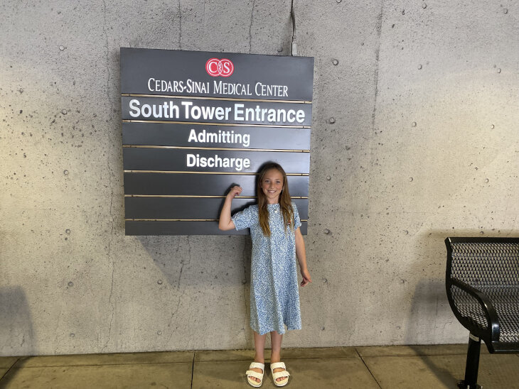

***Emmy visiting the NICU.***

Take concrete action. Sending [thank you notes](https://aish.com/the-art-of-saying-thank-you/) are a simple way to drastically increase happiness levels.

On Mother’s Day, our family tested this theory out. We went back to the NICU to show appreciation. We special-ordered pastries and delicacies, and we each wrote personalized notes and presented them to the staff.

As we drove up to the hospital, I was flooded with memories not only of my NICU baby, but of all of my babies and the various challenges and joys that came with them. Suddenly, I began to doubt if I was really ready to face the NICU staff.

Because of COVID, we were not allowed upstairs, but one nurse came down to greet us.

We introduced her to Emmy, who gave her a handwritten card, thanking her for saving her life.

I told the nurse, “When days get hard and you are exhausted, please know that you aren’t just saving babies. You are saving *families*. I am a happy mother because of your help. Because you helped save our Emmy, I had the strength to have more children. We are a more complete family because of you.”

**A Very Powerful Moment**

We all had tears in our eyes during that very powerful moment.

“You can’t imagine what this means to us,” the nurse said to us. ”Just the other day, a baby in the NICU passed. It’s so hard for us when that happens. This moment gives us strength.”

Even if your children were never in the NICU, we can all take a moment to express gratitude to anyone who helped us become the person we are today. Try it out—the results may surprise you.

Here’s my letter. May it inspire you to write your own letter to anyone that has affected your life.

*To the dedicated Staff of the NICU,*

*It has been eight years since our baby was in your care. She was rushed to the NICU for jaundice levels that were extremely dangerous. For one week, she was placed under the lights, hoping to bring the Bilirubin down. You worked around the clock feeding her, monitoring her, and making sure she was alive. You worked tirelessly to keep her safe and healthy. It is now eight years later, and I want to thank you with all my heart.*

***A Happy Family Because of Your Help***

*You have helped our family in more ways than you will ever know. Our daughter, Emmy, is now a young girl. She has the sweetest disposition. She loves to help her mommy in the kitchen, she loves to give charity, she loves basketball and reading and mint chocolate chip ice cream. She is a beautiful child with a sunny disposition. Together, we are a happy family because of your help.*

*Please remember that when you are hustling, working hard, and stretching yourself to help others your efforts are far reaching. When you think you have nothing left to give, know you are saving lives and families. You will never be forgotten. You are heroes.*

*Warmly,  
Pachter Family*

*Reprinted from the aish.com website on September 4, 2022. A version of this article originally appeared in Ami Magazine.*